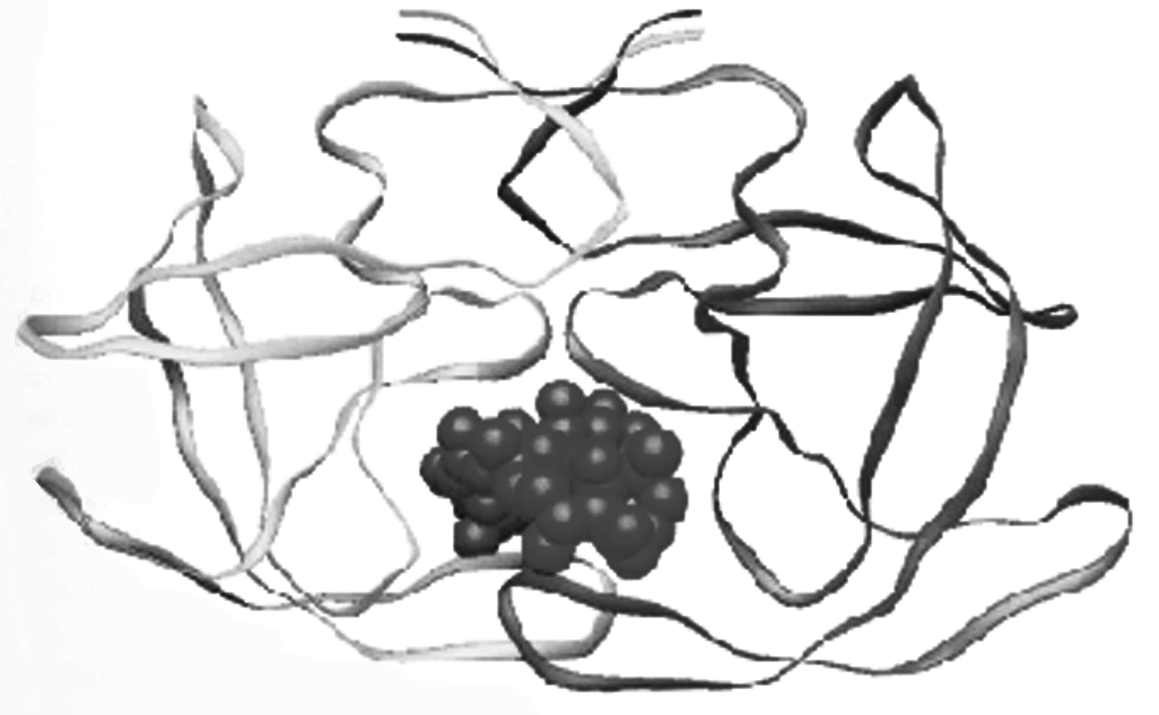
Peptides and Proteins

Protein folding

Proteins (polypeptides) are known to assume a variety of backbone conformations. In one conformation, the backbone is in almost fully extended arrangement (as in a parallel or anti–parallel β–sheet), and in another conformation it is in a fully folded arrangement (as in an α–helix).
7.1 The end–to–end distance in a hexapeptide when it is in a fully extended conformation is approximately :
- 10 Å
- 15 Å
- 20 Å
(d) 25 Å
1 mark
[Mark X in the correct box.]

Amino Acid | Structure | Molecular mass (Da)
Glu – Glutamic acid |  | 147
Hms – Homoserine |  | 119
Leu – Leucine |  | 131
Met – Methionine |  | 149
Lys – Lysine |  | 146
Phe – Phenylalanine |  | 165
Arg – Arginine |  | 174
Ser – Serine |  | 105

  - Assuming that the following hexapeptide is in α–helix conformation, draw a connecting arrow between an oxygen atom and an amide NH with which it is hydrogen bonded.

[1 mark for any correct answer; 0 for any wrong connections] 1 mark
  - The following two hexapeptides (A and B) display contrasting conformations in water at pH 7.0, especially when their serine hydroxyls are phosphorylated. A is moderately helical and it becomes a stronger helix on serine phosphorylation. B is weakly helical and it is completely disordered on serine phosphorylation. Draw connecting arrows to indicate the interactions between the residues that are responsible for this differing behaviour.

[0.5 mark for each correct arrow] 2 marks
Consider the following process of folding/unfolding of a tripeptide segment in a large
protein. The free energy change (ΔG) will depend on the interaction of the unfolded
tripeptide with the solvent (water) and with the rest of the protein in the folded state
(see below). Assume that the tripeptide is made up of one non–polar (hydrophobic;
shaded) and two polar (hydrophilic; unshaded) residues. Assume the following
approximate changes in the interaction free energies :

(a) a non–polar residue and the solvent (water)
ΔG = +8 kJ mol^{–1}
- a non–polar residue and the rest of the protein
ΔG = – 4 kJ mol^{–1}
- a polar residue and the solvent (water)
ΔG = – 16 kJ mol^{–1}
- a polar residue and the rest of the protein
ΔG = – 14 kJ mol^{–1}

polar residue
⇌ non-polar residue

Tripeptide segment in unfolded form Tripeptide segment in folded form

7.4 Calculate ΔG for the folding of the tripeptide segment.

ΔG = – 8 – (– 16 x 2) + (– 4 x 1) + (– 14 x 2) = – 8 kJ mol^{–1}

1 mark

7.5 Calculate ΔG for the folding of the tripeptide segment if all the three residues are polar.

ΔG = – (14 x 3) – (– 16 x 3) = + 6 kJ mol^{–1}

0.5 mark
β − lactamase and drug resistance
Penicillins are effective drugs in combating bacterial infections. An alarming development over the years has, however, been the emergence of drug resistant bacteria. Penicillin resistance arises due to the secretion of an enzyme called β–lactamase (also known as penicillinase), which inactivates penicillin by opening its β–lactam ring. The mechanism for this β–lactam ring opening involves the nucleophilic attack by serine–OH at the active site of the enzyme as shown below.

An attempt was made to characterize the β–lactamase from Staphylococcus aureus. When the pure enzyme was treated with a radiolabelled [³²P] phosphorylating agent, only the active site serine got labelled. On analysis, this serine {molecular mass = 105 mass units (Da)} constituted 0.35% by weight of the β–lactamase.
7.6 Estimate the minimal molecular mass of this β–lactamase.

105 x 100 = 30000 Da
0.35

1 mark

  - The approximate number of amino acid residues present in a protein of this size is :

- 100
- 150

- 275

- 375
[Mark X in the correct box.] 1 mark

7.8 To map its active site, the β–lactamase was hydrolysed using trypsin, a specific enzyme.
This resulted in a hexapeptide P1 containing the active site serine. Amino acid analysis revealed the following in equimolar proportion : Glu, Leu, Lys, Met, Phe and Ser.
Treatment of P1 with Edman’s reagent (phenyl isothiocyanate) yielded phenyl thiohydantoin (PTH) derivative of phenyalanine and a peptide P2.
Treatment of P1 with cyanogen bromide (CNBr) gave an acidic tetrapeptide P3 and a dipeptide P4.
Treatment of P2 with 1–fluoro–2,4–dinitrobenzene, followed by complete hydrolysis, yielded N–2,4–dinitrophenyl–Glu.
P1, P2, and P3 contain the active site serine.
From the above information, deduce the amino acid sequence of P1, P2, P3 and P4.
P1 : Phe – Glu – Ser – Met – Leu – Lys
P2 : Glu – Ser – Met – Leu – Lys
P3 : Phe – Glu – Ser – Hms/Met
P4 : Leu – Lys Hms = 1; Met = 0.5

4 marks

7.9 Calculate the molecular mass of P3 in mass units (Da) from the information given in the Table on page 32.
Phe – Glu – Ser – Hms

(165 + 147 + 105 + 119) – 3H₂O

= 536 – 54 = 482 Da

(1 mark : – 3H₂O) 1 mark
  - The β–lactamase active site provides a unique microenvironment that makes the catalytic serine–OH an unusually reactive nucleophile. The first order rate constant for β–lactamase catalysed reaction is 350 s^{–1}. For penicillin hydrolysis by free serine–OH (at 1M) in solution, the pseudo first order rate constant is 0.5 s^{–1}.
From the information above, calculate the effective concentration of this nucleophile at the enzyme active site?

700 M

1 mark
7.11 A molecule competing with penicillin for binding to the β–lactamase active site can inhibit the enzyme. Dissociation constants (K_{D}) for the inhibitor–lactamase complex for three different inhibitors are given below :
Inhibitor Dissociation constant (K_{D})
A 2.0 x 10^{–3}
B 1.0 x 10^{–6}
C 5.0 x 10^{–9}
Indicate which of these inhibitors is most effective in protecting penicillin against β–lactamase. [Mark X in the correct box]

A

B
C
1 mark
A β–lactamase inhibitor was designed rationally. On binding to the enzyme active
site, a nucleophilic attack by the OH group of serine resulted in the opening of the
β–lactam moiety of the inhibitor and elimination of Br–. A reactive electrophile is generated as a result and it captures an active site residue X, inactivating the enzyme.
7.12 Based on the above information, identify the electrophile (A) generated and the final product (B) formed in the enzyme inactivation by the inhibitor shown.

3 marks

