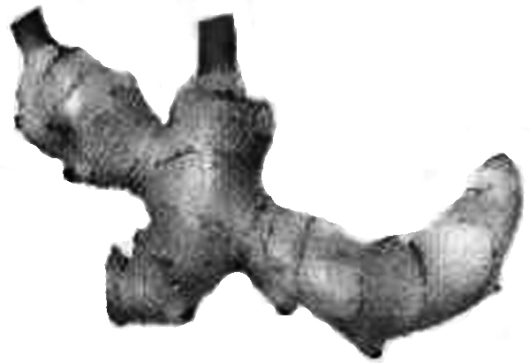
Organic chemistry of Indian spices

The rhizomes of ginger (Zingiber officinale) are well known for their medicinal and flavoring properties. In Ayurveda (the traditional system of medicine in India), different formulations of ginger are used for the treatment of gastrointestinal problems, common cold and other ailments. Several compounds are responsible for the pungency of ginger. Many are simple substituted aromatic compounds with different side chains. Three of them, Zingerone, (+)[6] Gingerol (to be referred hereafter as Gingerol only), and Shogaol are particularly important.
Zingerone C₁₁H₁₄O₃
Gingerol C₁₇H₂₆O₄
Shogaol C₁₇H₂₄O₃

  - Zingerone gives positive FeCl₃ and 2,4–DNP (2,4–dinitrophenylhydrazine) tests. It does not react with Tollen’s reagent. Therefore, Zingerone contains the following functional groups: [Mark X in the correct boxes.]

- alcoholic hydroxyl (e) ester

aldehydic carbonyl (f) alkoxyl

ketonic carbonyl (g) unsaturation
(d) phenolic hydroxyl
2 marks

The data obtained from the ¹H NMR spectrum of Zingerone are shown in Table 1. Some other relevant information is given in Table 2.

Table 1 : ¹H NMR spectral data* on Zingerone
Chemical shifts Multiplicity Relative intensity (δ)
2.04 singlet 3
2.69,271 two (closely spaced) triplets of equal intensity 4
3.81 singlet 3
5.90 broad singlet (D₂O exchangeable) 1
6.4 – 6.8 two doublets with similar chemical shifts 3
and one singlet

(* For clarity, some of the data have been altered slightly.)
Table 2 : Approximate ¹H chemical shifts (δ) and spin–spin coupling constants (J) of some protons.
¹H Chemical shifts (δ)

Spin–spin coupling constants (J)
Alkenes cis 5 – 14 Hz (commonly around 6 – 8 Hz)
trans 11− 19 Hz (commonly around 14 – 16 Hz)

Zingerone on bromination with bromine water gives only one nuclear mono brominated product. The IR spectrum of Zingerone indicates the presence of a weak intramolecular hydrogen bond. The same is present even after Clemmensen reduction (Zn–Hg/HCl) of Zingerone.

6.2 From the information above deduce the following :

i. side chain in Zingerone
CH₂CH₂COCH₃

ii. substituents on the aromatic ring
OH, OCH₃

iii. relative positions of the substituents
1, 2, 4

on the ring
3 marks
6.3 Draw a possible structure of Zingerone based on the above inferences.

3 marks
[Inference from mono bromination : 1 mark ; Inference from IR : 1 mark ; Inference from Clemmensen reduction : 1 mark]
6.4 Complete the following reaction sequence for the synthesis of Zingerone.

+ aq. NaOH

A B(C₃H₆O)

H₂/Catalyst Zingerone
C
(C₁₁H₁₄O₃)
[copy structure 6.4 A to page 30]
[Inference on C from Zingerone: 1 mark ; Inference on A and B from C: 2 marks] 3 marks
6.5 Zingerone can be easily converted into Gingerol by the following reaction sequence :

Notes : (1) is used to convert OH into −OSiMe₃; the group −SiMe₃ can be removed by acid hydrolysis.
(2) LDA is lithium diisopropylamide, a strong, very hindered, non–nucleophilic base.
- Draw the structure of D.

2 marks
[Inference from LDA, –78°C: 2 marks ; Inference from only LDA as a base: 1 mark]
ii. Draw the structure of Gingerol.

2 marks
[Addition of hexanal to the side chain: 1 mark]
- Complete the Fischer projection of the R− enantiomer of Gingerol.

1 mark

[Fischer projection of (ii): 1 mark]
- In the above reaction sequence (6.5), about 2–3% of another constitutional isomer (E) of Gingerol is obtained. Draw the likely structure of E.

1 mark
[Notion of positional isomer: 1 mark]
- Will the compound E be formed as
(a) a pair of enantiomers?

(b) a mixture of diastereomers?
(c) a mixture of an enantiomeric pair and a meso isomer?

[Mark X in the correct box.] 1 mark

- Gingerol (C₁₇H₂₆O₄) when heated with a mild acid (such as KHSO₄ ) gives Shogaol (C₁₇H₂₄O₃). Draw the structure of Shogaol.

1 mark
[Indication of plausible dehydration: 1 mark]

6.6 Turmeric (Curcuma longa) is a commonly used spice in Indian food. It is also used in Ayurvedic medicinal formulations. Curcumin (C₂₁H₂₀O₆), an active ingredient of turmeric, is structurally related to Gingerol. It exhibits keto–enol tautomerism. Curcumin is responsible for the yellow colour of turmeric and probably also for the pungent taste.
The ¹H NMR spectrum of the keto form of Curcumin shows aromatic signals similar to that of Gingerol. It also shows a singlet around δ 3.5 (2H) and two doublets (2H each) in the region δ 6–7 with J = 16 Hz. It can be synthesized by condensing TWO moles of A (refer to 6.4) with one mole of pentan–2,4–dione.
i. Draw the stereochemical structure of Curcumin.

6.4 A

3 marks
[Inference from NMR: COCH₂CO:0.5 mark; C=C: 0.5 mark; trans stereochemistry: 1 mark; condensation with dione: 1 mark]
ii. Draw the structure of the enol form of Curcumin

1 mark

- Curcumin is yellow in colour because it has

(a) a phenyl ring

(b) a carbonyl group
(c) an extended conjugation

(d) a hydroxyl group
1 mark

