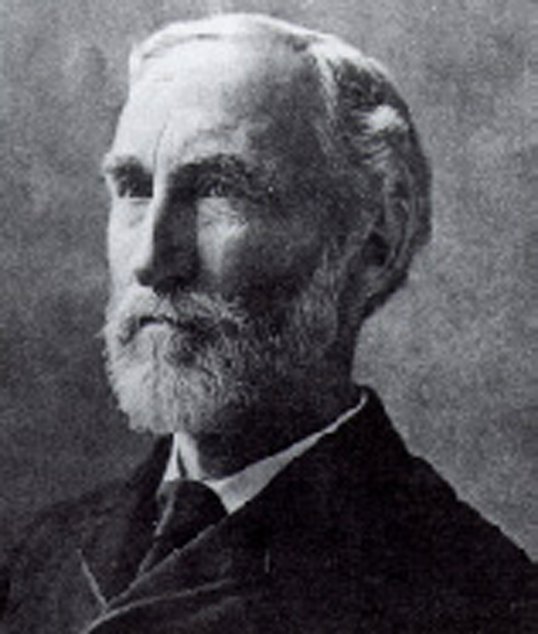
Second Law of Thermodynamics

The Second Law of Thermodynamics is a fundamental law
of science. In this problem we consider the thermodynamics
of an ideal gas, phase transition and chemical equilibrium.
J.W.Gibbs (1839 –1903)
3.00 mol of CO₂ gas expands isothermally (in thermal contact with the surroundings; temperature = 15.0ºC) against a fixed external pressure of 1.00 bar. The initial and final volumes of the gas are 10.0 L and 30.0 L, respectively.
  - Choose the correct option for change in the entropy of the system (ΔS_{sys}) and of the surroundings (ΔS_{sur}) :
(a) ΔS_{sys} > 0 ΔS_{sur} = 0

(b) ΔS_{sys} < 0 ΔS_{sur} > 0

(c) ΔS_{sys} > 0 ΔS_{sur} < 0
(d) ΔS_{sys} = 0 ΔS_{sur} = 0

[Mark X in the correct box.] 1 mark

3.2 Calculate ΔS_{sys}, assuming CO₂ to be an ideal gas.
Since ΔS_{sys} is independent of path, it is the same as for isothermal reversible expansion of an ideal gas.

(1)

= 27.4 JK⁻¹ (1)

${\text{ΔS}}_{\text{sys}}= \text{nR} \text{ln} \frac{V_{f}}{V_{i}}$

2 marks

3.3 Calculate ΔS_{sur}

q = p_{ext} ΔV (0.5)

(1)

${\text{ΔS}}_{\text{sur}}= −\frac{q}{T} = −6\text{.}\text{94} {\text{JK}}^{−1}$

1.5 marks
3.4 Calculate the change in entropy of the universe.

ΔS_{uni} = ΔS_{sys} + ΔS_{sur}

= 20.5 JK⁻¹

0.5 mark
Does your answer agree with the Second law of Thermodynamics?
[Mark X in the correct box.]

Yes No
0.5 mark
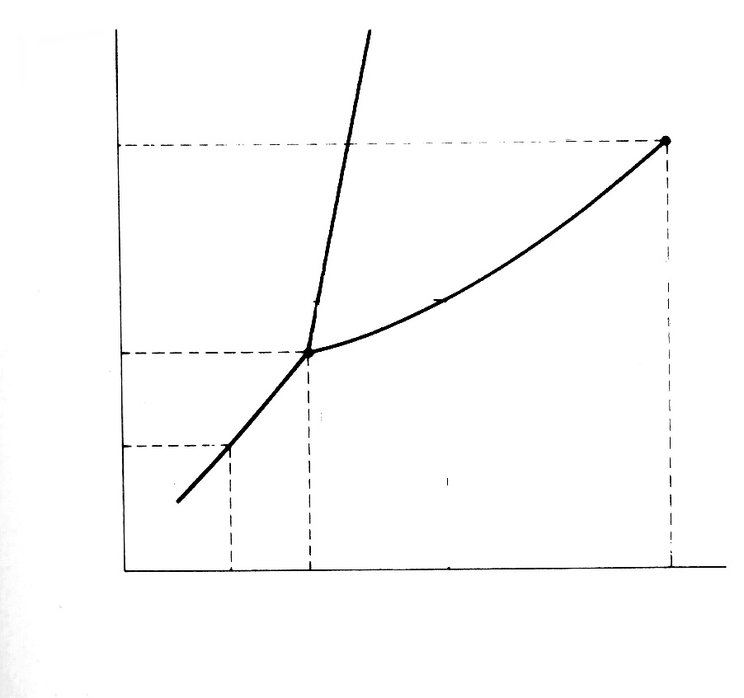
The pressure – temperature phase diagram of CO₂ is given below schematically. The diagram is not to scale.
P / bar
73.8
5.18
1.01
–78.5
–56.6
31.0
t / ºC
vapour
Phase diagram of CO₂
liquid
solid

3.5 CO₂ gas, initially at a pressure of 4.0 bar and temperature of 10.0 ºC, is cooled at constant pressure. In this process,
- it goes first to the liquid phase and

then to the solid phase.

- it goes to the solid phase without
going through the liquid phase.
[Mark X in the correct box.] 0.5 mark

3.6 Starting with the same pressure and temperature as above (in 3.5), CO₂ is compressed isothermally. In this process,
(a) it goes first to the liquid phase and
then to the solid phase.

(b) it goes to the solid phase without
going through the liquid phase.

[Mark X in the correct box.] 0.5 mark

  - From the data given in the phase diagram, calculate the molar enthalpy change of sublimation of CO₂. Write down the formula used.

$\begin{aligned}\text{ln}\frac{P_{2}}{P_{1}}=\frac{Δ{\overline{H}}_{\text{sub}}}{R}\left(\frac{1}{T_{1}}−\frac{1}{T_{2}}\right) \\ \\ \end{aligned}$

(1)

$Δ{\overline{H}}_{\text{sub}}$ = 26.1 kJ mol⁻¹ (1)

2 marks

3.8 CO gas, used extensively in organic synthesis, can be obtained by reacting CO₂ gas with graphite. Use the data given below to show that the equilibrium constant at 298.15 K is less than unity.
At 298.15 K
$ΔH _{f}^{o}$$S ^{ο}$ CO₂(g) : = −393.51 kJ mol⁻¹ ; = 213.79 JK⁻¹ mol⁻¹
$ΔH _{f}^{ο}$$S ^{ο}$ CO(g) : = −110.53 kJ mol⁻¹ ; = 197.66 JK⁻¹ mol⁻¹
$S ^{ο}$ C (graphite) : = 5.74 JK⁻¹ mol⁻¹
ΔHº = 172.45 kJ mol⁻¹ (0.5)
ΔSº = 176 JK⁻¹ mol⁻¹ (0.5)
ΔGº = ΔHº − TΔSº = 120 kJ mol⁻¹ (1)

ΔGº > 0 implies K < 1 (0.5)

2.5 marks
3.9 Estimate the temperature at which the reaction would have an equilibrium constant equal to 1. Ignore slight variations in the thermodynamic data with temperature.
ΔGº = 0 when ΔHº = TΔSº (0.5)

T = 980 K (0.5)

1 mark
  - The reaction above (in 3.8) is carried out between CO₂ and excess hot graphite in a reactor maintained at about 800ºC and a total pressure of 5.0 bar. The equilibrium constant K_{p} under these conditions is 10.0. Calculate the partial pressure of CO at equilibrium.
CO₂ (g) + C(s) ⇌ 2CO (g) 1−α 2α (0.5)

Partial 1 − α 2α (1)
pressure 1 + α 1 + α

x 5
x 5

K_{p} = p² (CO) / p (CO₂) (0.5)

p (CO) = 3.7 bar (1)

3 marks

