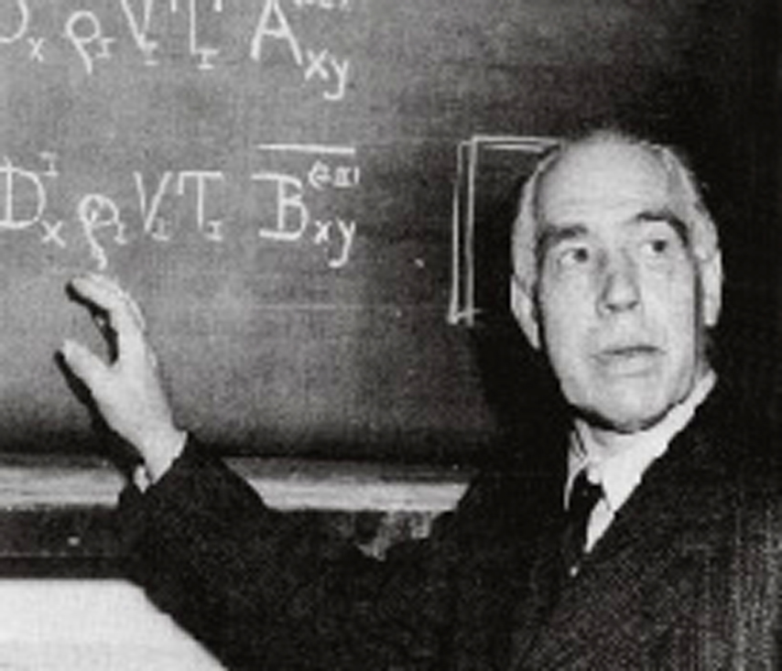
Hydrogen Atom and Hydrogen Molecule
Niels Bohr (1885-1962)
$\frac{1}{λ}\begin{matrix}\end{matrix}$The observed wavelengths in the line spectrum of hydrogen atom were first expressed in terms of a series by Johann Jakob Balmer, a Swiss teacher. Balmer’s empirical formula is
$R_{H}\text{ = }\frac{m_{e}{\text{ e}}^{4}}{{\text{8 ε}}_{0}^{2}{\text{ h}}^{3}\text{ c}}\text{ =}$Here, 109678 cm⁻¹
is the Rydberg constant. m_{e} is the mass of an electron. Niels Bohr derived this expression theoretically in 1913. The formula is easily generalized to any one-electron atom/ion.
  - Calculate the longest wavelength in Å (1Å = 10 ⁻¹⁰ m) in the ‘Balmer series’ of singly ionized helium (He⁺). Ignore nuclear motion in your calculation.
$\begin{aligned}\frac{1}{λ}\begin{matrix}=\begin{matrix}4{\text{ R}}_{H} (\frac{1}{2^{2}}−\frac{1}{n^{2}}) \end{matrix} & λ_{L}\text{ = } \text{1641}\text{.}1 Å\end{matrix} \\ \end{aligned}$
Longest wavelength $λ_{L}$corresponds to n = 3
For He⁺

(0.5)

(1)

1.5 marks
  - A formula analogous to Balmer’s formula applies to the series of spectral lines which arise from transitions from higher energy levels to the lowest energy level of hydrogen atom. Write this formula and use it to determine the ground state energy of a hydrogen atom in eV.
$\begin{aligned}\frac{1}{λ}\begin{matrix}=\begin{matrix}R_{H} (\frac{1}{1^{2}}−\frac{1}{n^{2}})\text{ ; n =}\begin{matrix}\text{2,3,4,}\text{.}\text{.}\text{.}\text{.}\end{matrix} & & E\begin{matrix}\end{matrix}\text{= }−−{\text{ h c R}}_{H} & \begin{matrix}\end{matrix} =−−\text{13}\text{.}6 \text{eV}\end{matrix}\end{matrix} \\ \end{aligned}$

(0.5)

(0.5)
(0.5)

1.5 marks
A ‘muonic hydrogen atom’ is like a hydrogen atom in which the electron is replaced by a heavier particle, the muon. The mass of a muon is about 207 times the mass of an electron, while its charge is the same as that of an electron. A muon has a very short lifetime, but we ignore its unstable nature here.
  - $a_{0}=\frac{ε_{0}h^{2}}{m_{e}e^{2}π}$Determine the lowest energy and the radius of the first Bohr orbit of the muonic hydrogen atom. Ignore the motion of the nucleus in your calculation. The radius of the first Bohr orbit of a hydrogen atom
(called the Bohr radius, ) is 0.53 Å.
Lowest energy = −207 x 13.6 = −2.82 keV (1)

Radius of the first Bohr orbit = 0.53 / 207 = 2.6 x 10⁻³ Å (1)

2 marks
The classical picture of an ‘orbit’ in Bohr’s theory has now been replaced by the quantum mechanical notion of an ‘orbital’. The orbital ψ_{1s} (r) for the ground state of a hydrogen atom is given by
$ψ_{1s}(r)=\frac{1}{\sqrt{{πa}_{o}^{3}}} ^{e^{−−r/a_{o}}}$

where r is the distance of the electron from the nucleus and a_{o} is the Bohr radius.
1.4 Consider a spherical shell of radius a_{o} and thickness 0.001a_{o}. Estimate the probability of finding the electron in this shell. Volume of a spherical shell of inner radius r and small thickness Δr equals 4πr² Δr.

Probability = ⏐$ψ$ (a_{o})⏐² 4πa_{o}² x 0.001a_{o} (1)

= 0.004 e⁻²
(1) = 5.41 x 10⁻⁴

2 marks
The H₂ molecule can dissociate through two different channels:
(i) H₂ → H + H (two separate hydrogen atoms)
(ii) H₂ → H⁺ + H⁻ (a proton and a hydride ion)
The graph of energy (E) vs internuclear distance (R) for H₂ is shown schematically in the figure. The atomic and molecular energies are given in the same scale.
1.5 Put appropriate channel labels (i) or (ii) in the boxes below.
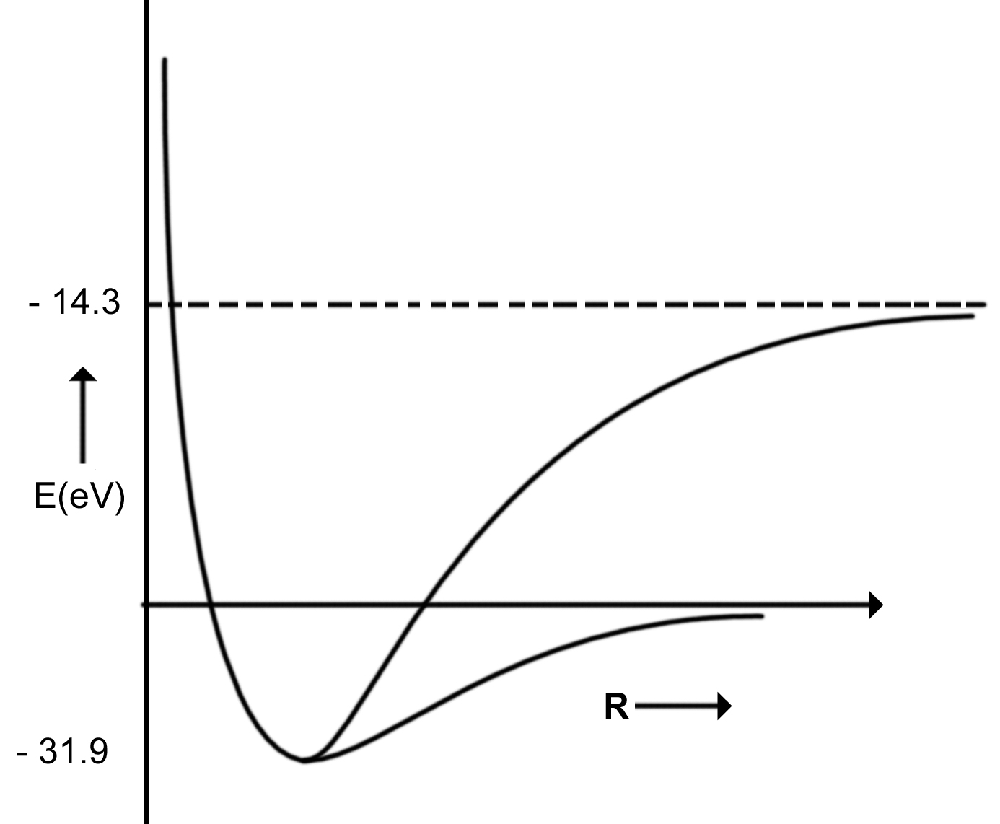
1 mark
(ii)
(i)

1.6 Determine the values of the dissociation energies (D_{e} in eV) of the H₂ molecule corresponding to
4.7 eV
eV

channel (i)
17.6 eV
channel (ii) 1 mark
  - From the given data, calculate the energy change for the process
H⁻ → H + e⁻

electron affinity = −13.6 – (−14.3) = 0.7 eV

1 mark

1.8 H⁻ is a two-electron atomic system. Assuming that the Bohr energy formula is valid for each electron with nuclear charge Z replaced by Z_{eff}, calculate Z_{eff} for H⁻.
−13.6 + 27.2 Z²_{eff} = 0.7 (1)
Z_{eff} = 0.7 (1)

2 marks

