Hard Water

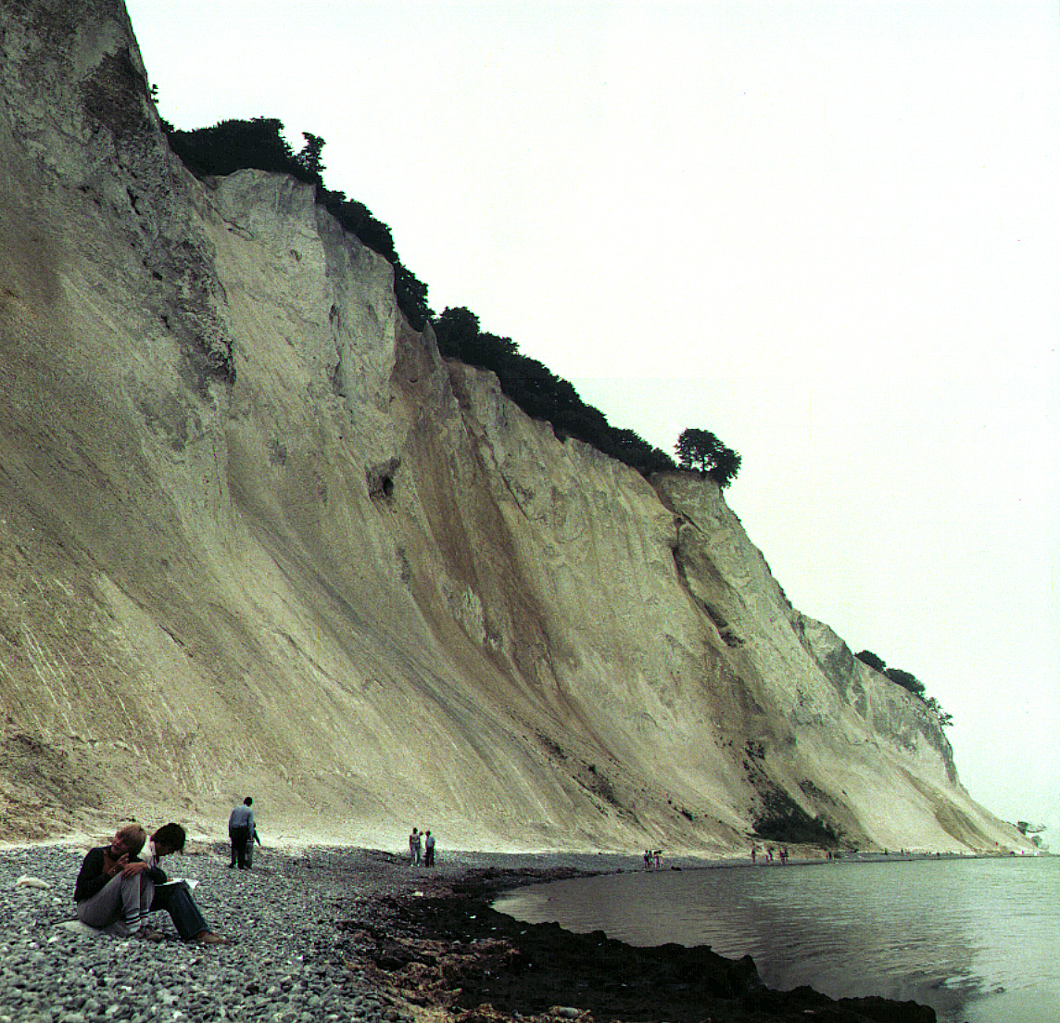

In Denmark the subsoil consists mainly of limestone. In contact with ground water containing carbon dioxide some of the calcium carbonate dissolves as calcium hydrogen carbonate. As a result, such ground water is hard, and when used as tap water the high content of calcium hydrogen carbonate causes problems due to precipitation of calcium carbonate in, for example, kitchen and bathroom environments.

Carbon dioxide, CO₂, is a diprotic acid in aqueous solution. The pK_{a}-values at 0 °C are:
CO₂(aq) + H₂O(l)  HCO₃– (aq) + H⁺(aq) pK_{a1} = 6.630
HCO₃– (aq)  CO₃^{2–} (aq) + H⁺(aq) pK_{a2} = 10.640

The liquid volume change associated with dissolution of CO₂ may be neglected for all of the following problems. The temperature is to be taken as being 0 °C.

- The total concentration of carbon dioxide in water which is saturated with carbon dioxide at a carbon dioxide partial pressure of 1.00 bar is 0.0752 m.
Calculate the volume of carbon dioxide gas which can be dissolved in one litre of water under these conditions.

^{The gas constant} R = 8.314 J mol–1 K–1 = 0.08314 L bar mol–1 K–1
L

- Calculate the equilibrium concentration of hydrogen ions and the equilibrium concentration of CO₂ in water saturated with carbon dioxide at a carbon dioxide partial pressure of 1.00 bar.

- Calculate the equilibrium concentration of hydrogen ions in a 0.0100 m aqueous solution of sodium hydrogen carbonate saturated with carbon dioxide at a carbon dioxide partial pressure of 1.00 bar.

- Calculate the equilibrium concentration of hydrogen ions in a 0.0100 m aqueous solution of sodium carbonate saturated with carbon dioxide at a carbon dioxide partial pressure of 1.00 bar. Ignore water dissociation effects.

- The solubility of calcium carbonate in water at 0 °C is 0.0012 g per 100 mL of water. Calculate the concentration of calcium ions in a saturated solution of calcium carbonate in water.

The hard groundwater in Denmark is formed via contact of water with limestone in the subsoil which reacts with carbon dioxide dissolved in the groundwater according to the equilibrium equation:

CaCO₃(s) + CO₂(aq) + H₂O(l)   Ca²⁺(aq) + 2 HCO₃– (aq)

The equilibrium constant, K, for this reaction is 10^{–4.25} m² at 0 °C.

- Calculate the concentration of calcium ions in water in equilibrium with calcium carbonate in an atmosphere with a partial pressure of carbon dioxide of 1.00 bar.

- A 0.0150 m solution of calcium hydroxide is saturated with carbon dioxide gas at a partial pressure of 1.00 bar. Calculate the concentration of calcium ions in the solution by considering the equilibrium equation given above in connection with problem 6-6.

- The calcium hydroxide solution referred to in problem 6-7 is diluted to twice the volume with water before saturation with carbon dioxide gas at a partial pressure of 1.00 bar. Calculate the concentration of calcium ions in the resulting solution saturated with CO₂.

- Calculate the solubility product constant for calcium carbonate from the data given above.

