A naturally occurring compound

A naturally occurring compound A containing only C, H and O has the following elemental composition, percentage mass,
C: 63.2 %, H: 5.3%, O: 31.5%.
- Derive the empirical formula of compound A.

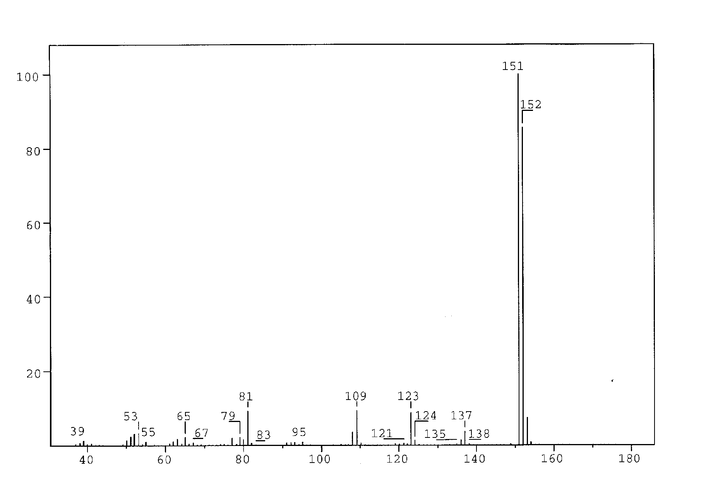
Figure 1

The mass spectrum of compound A is shown in Figure 1.

  - What is the molecular formula for compound A?

A solution of A in ether is shaken with an aqueous solution of NaOH. After this, no A remains in the ether phase.

Another solution of A in ether is shaken with an aqueous solution of NaHCO₃. A remains in the ether phase.

- Which of the following classes of compounds does A belong to according to these experiments? Mark with an X.

alcohol phenol aldehyde ketone

acid ester ether

Compound A gave rise to formation of a silver mirror with Tollens’ reagent (Ag(NH₃)₂⁺).

- Which of the following functional groups does this indicate the presence of in A?
Mark with an X.

hydroxy group of an alcohol hydroxy group of a phenol

carbonyl group of an aldehyde carbonyl group of a ketone

carboxylic group ester group

alkoxy group of an ether

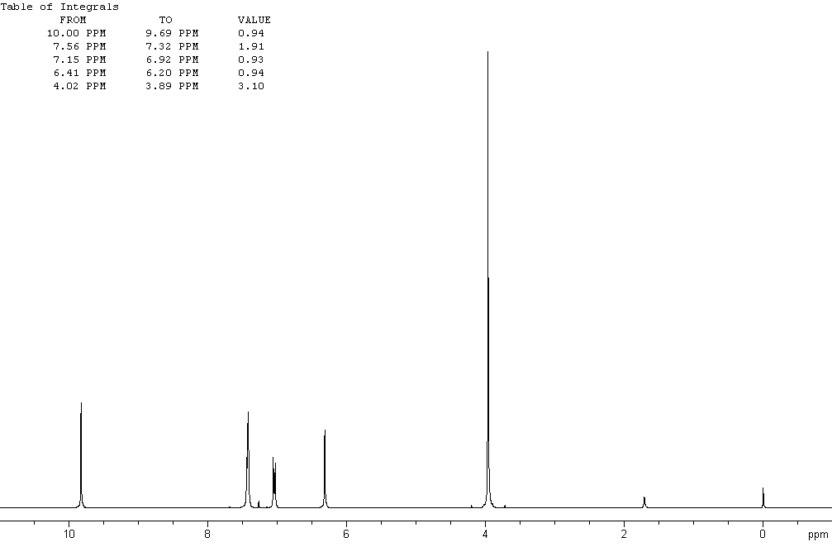

Figure 2a

The ¹H NMR spectrum of compound A recorded at 300 MHz is shown in Figure 2a (solvent CDCl₃ (7.27 ppm), reference tetramethylsilane). The signals at 3.9, 6.3 and 9.8 ppm are singlets. Figure 2b is an expansion of the region 6.9 –7.6 ppm.
Selected chemical shift and coupling constant values are given in Table 1.

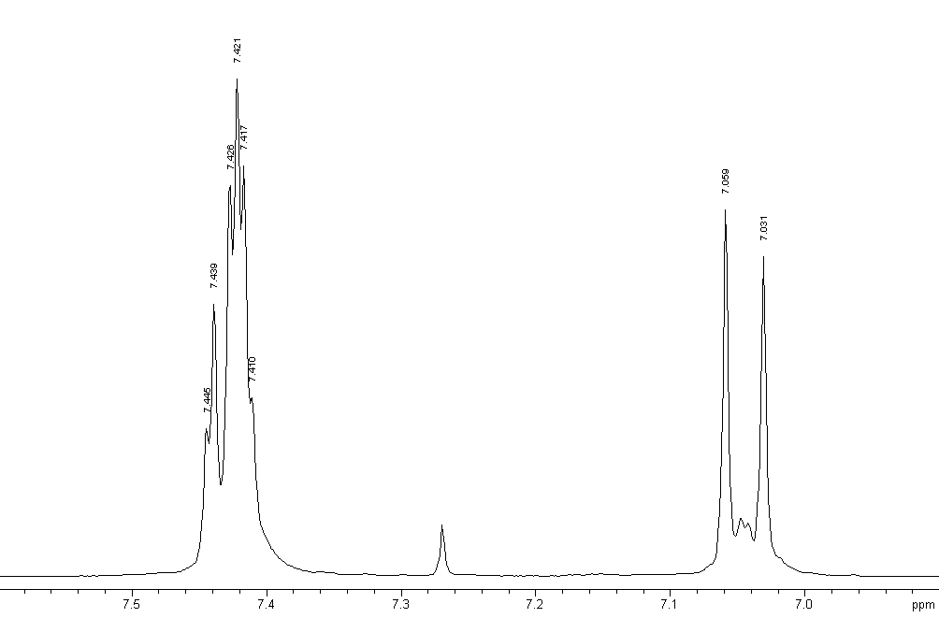

Figure 2b

The signal at 6.3 ppm disappears when a drop of D₂O is added.

- Which of the following does this indicate? Mark with an X.

Exchange of carbon-bonded hydrogen
Exchange of oxygen-bonded hydrogen
Dilution effect
Hydrolysis

The same signal moves to a lower ppm value upon dilution with CDCl₃.

- Which of the following does this indicate?
Indicate the true statements (more than one).

Increased hydrogen bonding
Decrease in hydrogen bonding
Intermolecular hydrogen bonding
Intramolecular hydrogen bonding
No hydrogen bonding

- Draw the four possible structural formulas for compound A based on the information given above

- Give structural formulas for the fragments lost corresponding to the peaks at 137 and 123 mass units in the mass spectrum.

- Two of the isomers have a lower pK_{a} value than the others. Write the formulas for those.

Table 1
¹H Chemical Shift δ

Hydrogens attached to carbon

Methyl | CH₃–C–  CH₃–C=O–  CH₃–O–R  CH₃–OCOR | 0.9 – 1.6 ppm  2.0 – 2.4 ppm  3.3 – 3.8 ppm  3.7 – 4.0 ppm
Methylene | CH₂–C–  CH₂–C=O–  CH₂–OR  CH₂–OCOR | 1.4 – 2.7 ppm  2.2 – 2.9 ppm  3.4 – 4.1 ppm  4.3 – 4.4 ppm
Methine | CH– | 1.5 – 5.0 ppm  depending on the substituents. Generally  higher than for methyl  and methylene
Alkene |  | 4.0 - 7.3 ppm  depending on the substituent
Aldehyde | R−CHO | 9.0 – 10.0 ppm
Hydrogens attached to oxygen

Alcohols | ROH | 0.5 -5.0 ppm
Phenols | ArOH | 4.0 - 7.0 ppm
Carboxylic acids | RCOOH | 10.0 - 13.0 ppm
Selected spin-spin coupling constants

Alkanes  (free notation) | H-C-C-H vicinal | 6 - 8 Hz
Alkenes | trans  cis  geminal | 11 - 18 Hz  6 - 12 Hz  0 - 3 Hz
Aromates | ortho  meta  para | 6 - 10 Hz  1 – 4 Hz  0 – 2 Hz

