A naturally occurring compound

A naturally occurring compound A containing only C, H and O has the following elemental composition, percentage mass,
C: 63.2 %, H: 5.3%, O: 31.5%.
- Derive the empirical formula of compound A.

C₈H₈O₃

1 mark
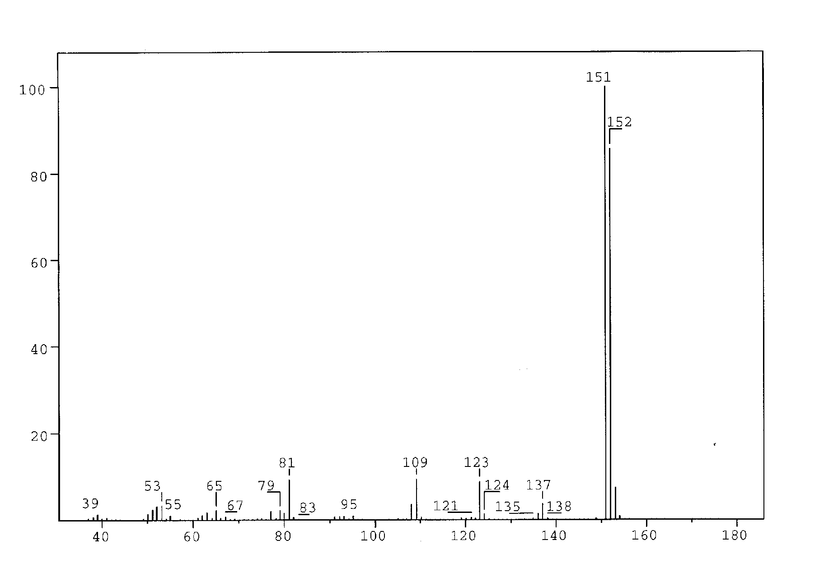
Figure 1
The mass spectrum of compound A is shown in Figure 1.

  - What is the molecular formula for compound A?

C₈H₈O₃

1 mark

A solution of A in ether is shaken with an aqueous solution of NaOH. After this, no A remains in the ether phase.

Another solution of A in ether is shaken with an aqueous solution of NaHCO₃. A remains in the ether phase.

- Which of the following classes of compounds does A belong to according to these experiments? Mark with an X.

alcohol phenol aldehyde ketone

acid ester ether
1 mark

Compound A gave rise to formation of a silver mirror with Tollens’ reagent (Ag(NH₃)₂⁺).

- Which of the following functional groups does this indicate the presence of in A?
Mark with an X.

hydroxy group of an alcohol hydroxy group of a phenol

carbonyl group of an aldehyde carbonyl group of a ketone

carboxylic group ester group

alkoxy group of an ether
1 mark

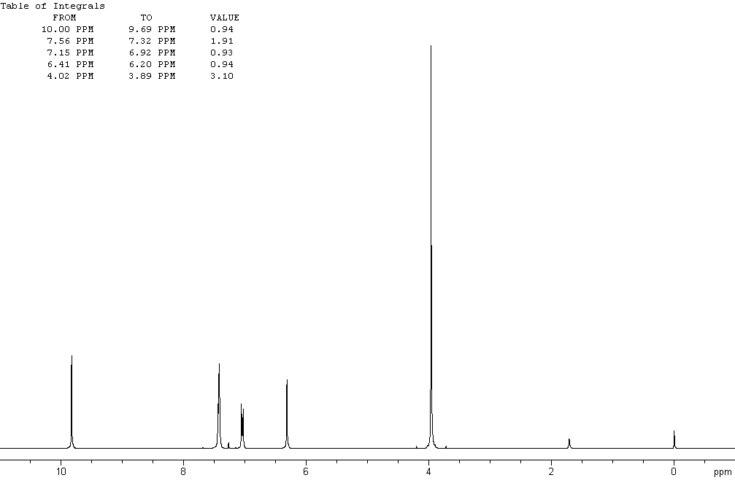

Figure 2a

The ¹H NMR spectrum of compound A recorded at 300 MHz is shown in Figure 2a (solvent CDCl₃ (7.27 ppm), reference tetramethylsilane). The signals at 3.9, 6.3 and 9.8 ppm are singlets. Figure 2b is an expansion of the region 6.9 –7.6 ppm.
Selected chemical shift and coupling constant values are given in Table 1.

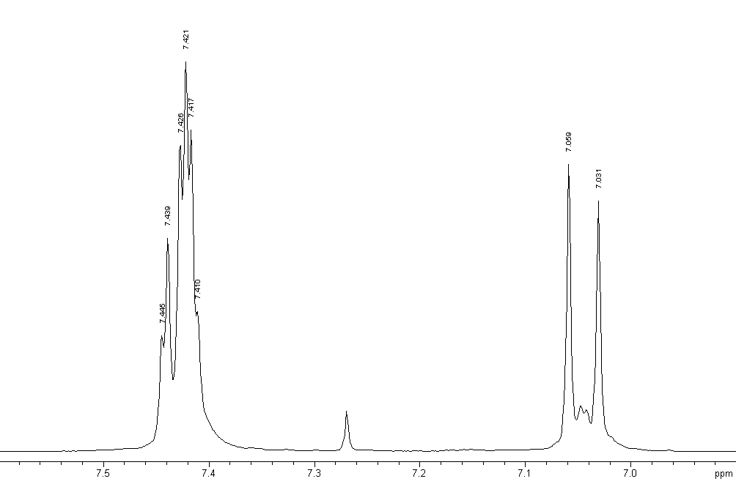

Figure 2b
The signal at 6.3 ppm disappears when a drop of D₂O is added.

- Which of the following does this indicate? Mark with an X.

Exchange of carbon-bonded hydrogen
Exchange of oxygen-bonded hydrogen
Dilution effect
Hydrolysis
1 mark

The same signal moves to a lower ppm value upon dilution with CDCl₃.

- Which of the following does this indicate?
Indicate the true statements (more than one).

Increased hydrogen bonding
Decrease in hydrogen bonding
Intermolecular hydrogen bonding
Intramolecular hydrogen bonding
No hydrogen bonding
2 marks

- Draw the four possible structural formulas for compound A based on the information given above

4 mark

- Give structural formulas for the fragments lost corresponding to the peaks at 137 and 123 mass units in the mass spectrum.
CH₃
1 mark
HC=O

- Two of the isomers have a lower pK_{a} value than the others. Write the formulas for those.

1 mark

Table 1
¹H Chemical Shift δ

Hydrogens attached to carbon

Methyl | CH₃–C–  CH₃–C=O–  CH₃–O–R  CH₃–OCOR | 0.9 – 1.6 ppm  2.0 – 2.4 ppm  3.3 – 3.8 ppm  3.7 – 4.0 ppm
Methylene | CH₂–C–  CH₂–C=O–  CH₂–OR  CH₂–OCOR | 1.4 – 2.7 ppm  2.2 – 2.9 ppm  3.4 – 4.1 ppm  4.3 – 4.4 ppm
Methine | CH– | 1.5 – 5.0 ppm  depending on the substituents. Generally  higher than for methyl  and methylene
Alkene |  | 4.0 - 7.3 ppm  depending on the substituent
Hydrogens attached to oxygen

Alcohols | ROH | 0.5 -5.0 ppm
Phenols | ArOH | 4.0 - 7.0 ppm
Carboxylic acids | RCOOH | 10.0 - 13.0 ppm
Selected spin-spin coupling constants

Alkanes  (free rotation) | H-C-C-H vicinal | 6 - 8 Hz
Alkenes | trans  cis  geminal | 11 - 18 Hz  6 - 12 Hz  0 - 3 Hz
Aromates | ortho  meta  para | 6 - 10 Hz  1 – 4 Hz  0 – 2 Hz

Protein and DNA

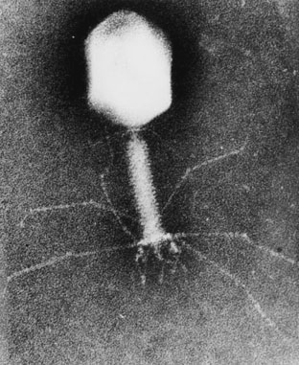

DNA is composed of 2’-deoxy-nucleotides carrying the bases adenine (A), guanine (G), cytosine (C) and thymine (T). The molar mass of the 2’-deoxy-nucleotide-5’-triphosphates is given in table 2:

Table 2  dNTP | Molar mass /g mol^{–1}
dATP | 487
dGTP | 503
dCTP | 464
dTTP | 478

- Calculate the molar mass of a double stranded DNA fragment consisting of 1000 base pairs with a uniform distribution of the four bases.

dNTP average mass = 483 g mol^{–1}; M(HP₂O₇²⁻) = 175 g mol^{–1};
1000 bp double stranded DNA
M(DNA) = ((483-175) · 2 · 1000 + 2 · 17) g mol^{–1}
= 616034 g mol^{–1}

2 marks

This DNA fragment can be isolated and cloned by using the PCR method (polymerase chain reaction), in which a heat stable DNA polymerase enzyme multiplies the number of molecules of a specific piece of DNA in a cyclic process. Under optimal conditions the number of double-stranded DNA copies doubles in each cycle.

Using the PCR method you perform 30 cycles starting from a single double stranded DNA molecule.

- Calculate the approximate mass of the DNA you obtain from this experiment.

2³⁰ copies = 1073741824 copies
Total mass of DNA: m(DNA) = 1073741824/N_{A} · 616350 g mol^{–1} = 1.1 ng

2 marks

The bacteria-virus T4 enzyme - polynucleotide kinase (PNK) catalyzes the transfer of the terminal phosphate of ATP (γ-orthophosphate) to the 5'-hydroxyl termini of ribo- and deoxyribonucleotides:

PNK is commonly used to label DNA at the 5’-end with the radioactive phosphorus isotope ³²P using ATP in which the γ-P (the outermost of the phosphorus atoms) is replaced with ³²P. The amount of ³²P and thus the amount of labelled DNA can be measured.

A 10 µL solution containing double stranded DNA is labelled 100% with [γ-³²P]ATP by PNK. 37 days ago, the specific activity of [γ-³²P]ATP was 10 Ci/mmol or 370 ·10⁹ Bq/mmol. ³²P has a half-life of 14.2 days, and during the decay a β-particle is emitted. Now the labelled DNA emits 40000 β-particles/s.

- Calculate the concentration of the DNA solution.

A = A₀e^{-kt} and k = $\frac{\text{ln}2}{t_{1/2}}$ ⇒ A₀ = dps = 243464 dps
which corresponds to $\frac{\text{243464}}{\text{370}}$pmol 5’-³²P-DNA = 658 pmol 5’-³²P-DNA
Since volumen of the labelled DNA is 10 µL, the concentration of the DNA is thus approx. 66 µm
2 marks

In an experiment in which PNK is incubated with [γ-³²P]ATP and single stranded DNA, the reaction can be monitored by isolating labeled DNA and measuring the β-particle emission.

Using this kind of measurements in a 1 mL experimental mixture, a labeling of
9 nmol DNA/min was calculated. PNK has a catalytic rate constant (turnover number) of 0.05 s^{–1} and molar mass of 34620 g mol^{–1}.

- Calculate the concentration (in mg/mL) of PNK in the experimental mixture.

Since 9 nmol DNA is labeled per min and the turnover number is
0.05 s⁻¹, the amount of PNK that catalyses the labeling is:
$\frac{\text{9 nmol/min}}{0\text{.}{\text{05 s}}^{\text{-1}}⋅\text{ 60 s/min}}$ =
3 nmol, which corresponds to 3 nmol · 34620 g mol^{–1} = 0.1 mg
The concentration of the PNK in mg/mL is thus 0.1 mg/mL

2 marks

Aromatic amino acids, tryptophan, tyrosine and phenylalanine absorb UV light of a wavelength between 240 nm and 300 nm.

In a protein containing several aromatic amino acids, the sum of the molar absorptivity per amino acid Σε_{amino acid}, is approximately equal to the molar absorptivity, ε_{protein} , for the protein.

The molar absorptivity, ε_{amino acid}, at 280 nm for tyrosine, tryptophan and phenylalanine is 1400 m^{–1} cm^{–1}, 5600 m^{–1} cm^{–1} and 5 m^{–1} cm^{–1}, respectively. The absorbance of a 10 µm solution of PNK is 0.644 at 280 nm and with 1.00 cm light path. The amino acid sequence of PNK contains 14 tyrosines and 9 phenylalanines.

- Calculate the number of tryptophan residues in a PNK molecule.

ε_{Tryptophan} = 5600 m^{–1}cm^{–1}; ε_{Tyrosine} = 1400 m^{–1}cm^{–1}; ε_{phenylalanine} = 5 m^{–1} cm^{–1}
ε = $\frac{A}{c⋅l}$ ⇒ ε_{PNK} = $\frac{0\text{.}\text{644}}{\text{10 }μM⋅1\text{.}\text{00}\text{cm}}$ = 64400 m^{–1} cm^{–1}
Σ(ε_{Tyrosine} + ε_{phenylalanine}) = (14 ·1400 + 9 · 5) m^{–1}cm^{–1} = 19645 m^{–1}cm^{–1}
Σε_{Tryptophan} = ε_{PNK} – Σ(ε_{Tyrosine} + ε_{phenylalanine}) ⇒
Σε_{Tryptophan} = (64400 – 19645) m^{–1}cm^{–1} = 44755 m^{–1}cm^{–1}
The number of tryptophan residues in a PNK molecule is thus: $\frac{\text{44755 }M^{\text{-1}}{\text{cm}}^{\text{-1}}}{\text{5600 }M^{\text{-1}}{\text{cm}}^{\text{-1}}}$ = 8 residues

2 marks

Hard Water

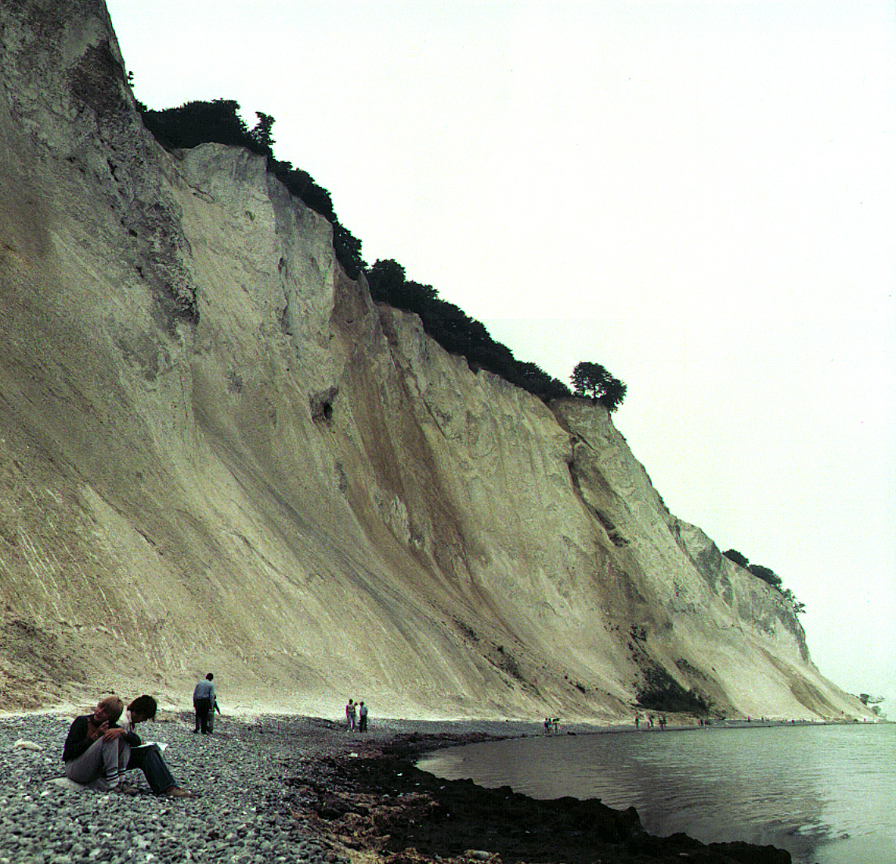

In Denmark the subsoil consists mainly of limestone. In contact with ground water containing carbon dioxide some of the calcium carbonate dissolves as calcium hydrogen carbonate. As a result, such ground water is hard, and when used as tap water the high content of calcium hydrogen carbonate causes problems due to precipitation of calcium carbonate in, for example, kitchen and bathroom environments.

Carbon dioxide, CO₂, is a diprotic acid in aqueous solution. The pK_{a}-values at 0 °C are:
CO₂(aq) + H₂O(l) = HCO₃– (aq) + H⁺(aq) pK_{a1} = 6.630
HCO₃– (aq) = CO₃^{2–} (aq) + H⁺(aq) pK_{a2} = 10.640

The liquid volume change associated with dissolution of CO₂ may be neglected for all of the following problems. The temperature is to be taken as being 0 °C.

- The total concentration of carbon dioxide in water which is saturated with carbon dioxide at a carbon dioxide partial pressure of 1.00 bar is 0.0752 m.
Calculate the volume of carbon dioxide gas which can be dissolved in one litre of water under these conditions.

^{The gas constant} R = 8.314 J mol–1 K–1 = 0.08314 L bar mol–1 K–1
c(CO₂) = 0.0752 m n(CO₂) = 0.0752 mol
The ideal gas equation: pV = nRT
1.00 bar × V = 0.0752 mol × 0.08314 L bar mol^{–1} K^{–1} × 273.15 K
V = 1.71 L

2 mark

- Calculate the equilibrium concentration of hydrogen ions and the equilibrium concentration of CO₂ in water saturated with carbon dioxide at a carbon dioxide partial pressure of 1.00 bar.

CO₂(aq) + H₂O(l) = HCO₃– (aq) + H⁺(aq)

[H⁺] = [HCO₃–] = x and [CO₂] + [HCO₃–] = 0.0752 m

K_{a} = 10^{–6.63} m = $\frac{[H^{+}][{\text{HCO}}_{3}^{−}]}{[{\text{CO}}_{2}]}$ = $\frac{x^{2}}{0\text{.}\text{0752}M−x}$

[H⁺] = 0.000133 m and [CO₂] = 0.0751 m

1 mark

- Calculate the equilibrium concentration of hydrogen ions in a 0.0100 m aqueous solution of sodium hydrogen carbonate saturated with carbon dioxide at a carbon dioxide partial pressure of 1.00 bar. Ignore water dissociation effects.

CO₂(aq) + H₂O(l) = HCO₃– (aq) + H⁺(aq)
[CO₂] = 0.0751 m and [HCO₃–] = 0.0100 m
K_{a} = 10^{–6.63} m = $\frac{[H^{+}][{\text{HCO}}_{3}^{−}]}{[{\text{CO}}_{2}]}$ = $\frac{x´0\text{.}\text{0100}M}{0\text{.}\text{0751}M}$
x = [H⁺] = 1.76 × 10^{–6} m

1 mark

- Calculate the equilibrium concentration of hydrogen ions in a 0.0100 m aqueous solution of sodium carbonate saturated with carbon dioxide at a carbon dioxide partial pressure of 1.00 bar. Ignore water dissociation effect.

CO₂(aq) + CO₃^{2–} (aq) + H₂O(l) → 2 HCO₃– (aq) [HCO₃–] = 0.0200 m
CO₂(aq) + H₂O(l) = HCO₃– (aq) + H⁺(aq)
K_{a} = 10^{–6.63} m = $\frac{[H^{+}][{\text{HCO}}_{3}^{−}]}{[{\text{CO}}_{2}]}$ = $\frac{x´0\text{.}\text{0200}M}{0\text{.}\text{0751}M}$
x = [H⁺] = 8.8 × 10^{–7} m

2 marks
- The solubility of calcium carbonate in water at 0 °C is 0.0012 g per 100 mL of water. Calculate the concentration of calcium ions in a saturated solution of calcium carbonate in water.

0.0012 g CaCO₃ in 100 ml of water
0.0012 g /100.0872 g mol^{–1} = 0.000012 mol CaCO₃ in 100 mL of water
[Ca²⁺] = 1.2 × 10^{–4} m

1 mark

The hard groundwater in Denmark is formed via contact of water with limestone in the subsoil which reacts with carbon dioxide dissolved in the groundwater according to the equilibrium equation:

CaCO₃(s) + CO₂(aq) + H₂O(l) = Ca²⁺(aq) + 2 HCO₃– (aq)

The equilibrium constant, K, for this reaction is 10^{–4.25} m² at 0 °C.

- Calculate the concentration of calcium ions in water in equilibrium with calcium carbonate in an atmosphere with a partial pressure of carbon dioxide of 1.00 bar.

K = $\frac{[{\text{Ca}}^{2+}][{\text{HCO}}_{3}^{−}]^{2}}{[{\text{CO}}_{2}]}$ = 10^{–4.25} m² and 2 [Ca²⁺] = [HCO₃–]
$\frac{4 [{\text{Ca}}^{2+}]^{3}}{0\text{.}\text{0751} M}$= 10^{–4.25} m² [Ca²⁺] = 1.02 × 10^{–2} m

3 marks

- A 0.0150 m solution of calcium hydroxide is saturated with carbon dioxide gas at a partial pressure of 1.00 bar. Calculate the concentration of calcium ions in the solution by considering the equilibrium equation given above in connection with problem 6-6.

c(Ca(OH)₂) = 0.015 m
OH– (aq) + CO₂(aq) → HCO₃– (aq)
All hydroxide has been consumed (K = 10^{7.37} m^{–1}).
From problem 6-6 we found that the maximum possible calcium ion concentration is smaller, i.e. precipitation of CaCO₃
[Ca²⁺] = 1.02 × 10^{–2} m

3 marks

- The calcium hydroxide solution referred to in problem 6-7 is diluted to twice the volume with water before saturation with carbon dioxide gas at a partial pressure of 1.00 bar. Calculate the concentration of calcium ions in the resulting solution saturated with CO₂.

c(Ca(OH)₂) = 0.0075 m
From problem 6-6 we found that the maximum possible calcium ion concentration we can have is 1.02 × 10^{–2} m, i.e. no precipitation
[Ca²⁺] = 0.75 × 10^{–2} m

2 marks

- Calculate the solubility product constant for calcium carbonate from the data given above.

K = $\frac{[{\text{Ca}}^{2+}][{\text{HCO}}_{3}^{−}]^{2}}{[{\text{CO}}_{2}]}$ = $\frac{[{\text{Ca}}^{2+}][{\text{HCO}}_{3}^{−}]^{2}}{[{\text{CO}}_{2}]}$ × $\frac{[{\text{CO}}_{3}^{2−}][H^{+}]}{[{\text{CO}}_{3}^{2−}][H^{+}]}$ = $\frac{K_{\text{sp}}K_{\text{a1}}}{K_{\text{a2}}}$
K_{sp} = 10^{–8.26} m²

3 marks

