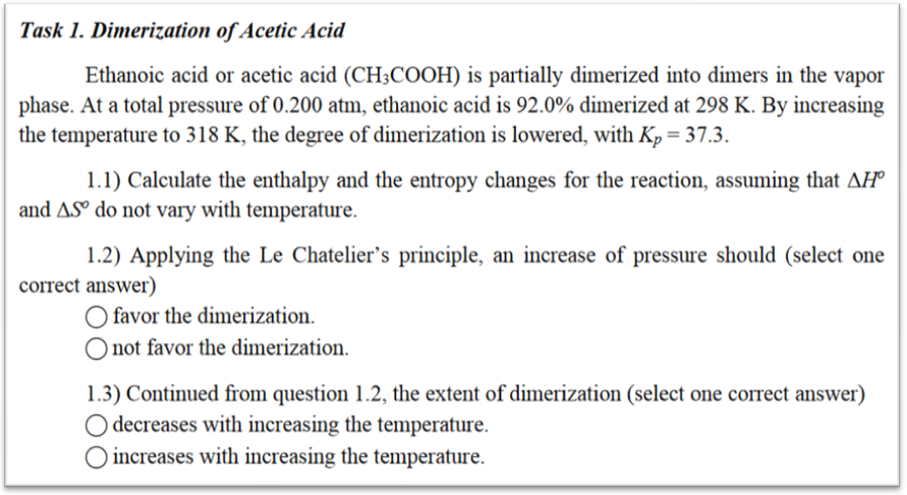
Task 1. Solution
1.1)The dimerization reaction in the vapor phase is 2CH₃COOH → (CH3COOH)₂ leading to the cyclic dimer. Assuming a container of unitary volume (1 m³ or 1 L), and Perfect Gas behavior in the system, at 0.200 atm and 298 K the total equilibrium moles are:
n_{tot} = PV/(RT) = 20265 Pa ⋅ 1 m³ /(8.3145 ⋅ 298 K) = 8.178 mol
The total equilibrium moles are the sum of each species’ equilibrium moles, thus by taking λ as the formed quantity of acetic acid dimer (reaction extent), we obtain:
n_{tot} = n_{AA} + n_{AAdim} = (n_{AA,in} – 2λ) + λ = n_{AA,in} – λ = 8.178 mol
Since we know that 92% of n_{AA,in} is dimerized, or that 92% of the initial moles have reacted, then 0.92⋅n_{AA,in} = 2λ, therefore λ = 0.46⋅n_{AA,in}, thus we obtain the reaction extent:
n_{AA,in} – 0.46⋅n_{AA,in} = 8.178 mol → n_{AA,in} = 15.14 mol
λ = 0.46⋅n_{AA,in} → λ = 6.966 mol
From this, all the equilibrium molar fractions and partial pressures are known:
x_{AA} = n_{AA}/n_{tot} = (n_{AA,in} – 2λ)/n_{tot} = 0.1477 → p_{AA} = 0.1477⋅P =0.02954 atm
x_{AAdim} = 1 – x_{AA} = 0.8533 → p_{AAdim} = 0.8533⋅P =0.17046 atm
Now we can evaluate K_{p}(298 K) = a_{AAdim}/(a_{AA})² where a_{j} = p_{j}/(1 atm), in order to recover the dimensionality of the equilibrium constant, we obtain K_{p}(298 K) = 195.34, which is consistent to the next statement: as the reaction extent decreases at a given temperature, so will the equilibrium constant. From the thermodynamic definition of equilibrium constant, we have:
K_{p}(T) = exp(–Δ_{R}g(T)/(RT))
Thus, we proceed to calculate Δ_{R}g(T) for the dimerization reaction at both temperatures:
Δ_{R}g(318 K) = –RT⋅ln(K_{p}(298 K)) = –8.3145 ⋅ 298 K ⋅ln(195.34) = –13.069 kJ/mol
Δ_{R}g(318 K) = –RT⋅ln(K_{p}(318 K)) = –8.3145 ⋅ 318 K ⋅ ln(37.30) = –9.568 kJ/mol
Moreover, since by assumption Δ_{R}g(T) = Δ_{R}h – T⋅Δ_{R}s, we have 2 equations in 2 unknowns (alternatively, we could’ve used the Van’t Hoff relation to directly obtain Δ_{R}h):
–13.069 kJ/mol = Δ_{R}h – 298 K⋅ Δ_{R}s
–9.568 kJ/mol = Δ_{R}h – 318 K⋅ Δ_{R}s
Then Δ_{R}s = –0.175 kJ/(mol K) and Δ_{R}h = –65.23 kJ/mol. The signs are consistent with the reaction chemistry, as the entropy decreases (decrease of moles) and enthalpy decreases (bonds are formed). We can verify the consistency by using Van’t Hoff relation, giving directly the enthalpy of reaction.
1.2) Since the reaction decreases the number of moles, an increase of pressure at fixed temperature does not change the equilibrium constant, but increases the dimerized fraction.
1.3)Since the equilibrium constant decreases by increasing the temperature, an increase of temperature decreases the dimerized fraction.
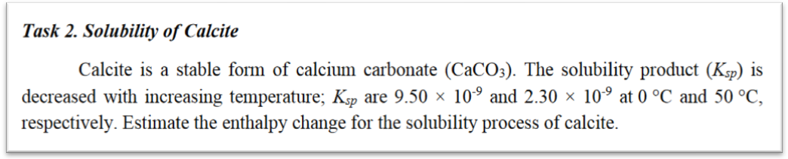
Task 2. Solution
The enthalpy change of the reaction can be estimated from the Van’t Hoff relation:
Where R = 8.3145 J/(mol K), T₁ = 273.15 K, ln(K₁) = –18.47, and for the latter T₂ = 323.15 K, ln(K₂) = –19.89. We can first estimate that Δ_{R}h will have positive sign, since by increasing the temperature, the equilibrium constant will decrease. By substitution:
We have thus verified our initial assumption, and Δ_{R}h = 20.84 kJ/mol.
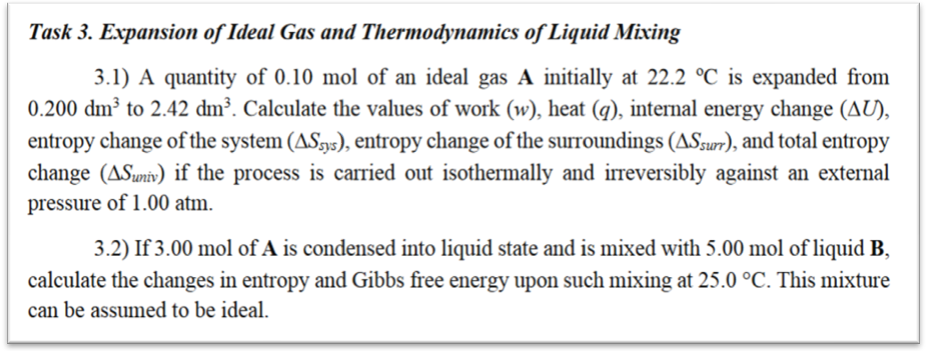
Task 3. Solution
3.1) The isothermal irreversible expansion of a Perfect Gas in a closed system proceeds with zero internal energy change, thus immediately ΔU = 0. From the 1st Law, ΔU = q + w = 0, thus q = –w, using the IUPAC convention (energy released from the system has minus sign, and energy gained by the system has plus sign). In this way, if work is done on the system (W> 0), the system releases that energy as heat (Q< 0) if the temperature is constant.
The initial pressure P₁ = nRT/V₁ = 0.10 mol ⋅ 8.3145 ⋅ 295.35 K/2×10^{–4} m³ = 12.12 atm, and the final pressure inside the system is P₂ = P₁⋅V₁/V₂ = 12.12 atm ⋅ 0.2/2.42 = 1.002 atm, which is greater than the external pressure. The resulting energy released as work is (an irreversible transformation) negative, as w = P_{ext}⋅(V₁ – V₂) = 101325 Pa ⋅ (0.2 – 2.42)×10^{–3} m³ = –224.9 J, and the resulting heat absorbed by the system is q=–w = 224.9 J.
From the fundamental thermodynamic relation, dU = TdS – PdV, which is valid upon quasi-static processes and irreversible processes, yields that if dU = 0, then ΔS_{sys} = PΔV/T, and since PΔV is the irreversible work done by the system, ΔS_{sys} = w/T = –0.761 J/K. The entropy change of the system is consistent since the system’s constituents, particles, have an increased space or motional freedom. Since by the 2nd Law, ΔS_{univ}= ΔS_{surr} + ΔS_{sys} ≥ 0, with zero entropy production (no other sources of entropic production apart from expansion), we have that the inequality becomes equality, ΔS_{univ}= 0and ΔS_{surr} = –ΔS_{sys} = 0.761 J/K.
3.2) The entropy change expected when two or more ideal substances are mixed is called mixing entropy, and it’s derived from the fundamental thermodynamic relation. If the mixture is Perfect, then Δ_{mix}g = –T⋅Δ_{mix}s, where Δ_{mix}s = –n_{tot}R⋅(x₁ ln x₁ + x₂ ln x₂) where x is the molar fraction of each component. From the data, x₁ = 3/8 and x₂ = 5/8, and n_{tot} = 8 mol, therefore we obtain Δ_{mix}s = –8 mol ⋅ 8.3145 ⋅(3/8 ln(3/8) + 5/8 ln(5/8)) = 44 J/K, and Δ_{mix}g = 13.11 kJ/mol.
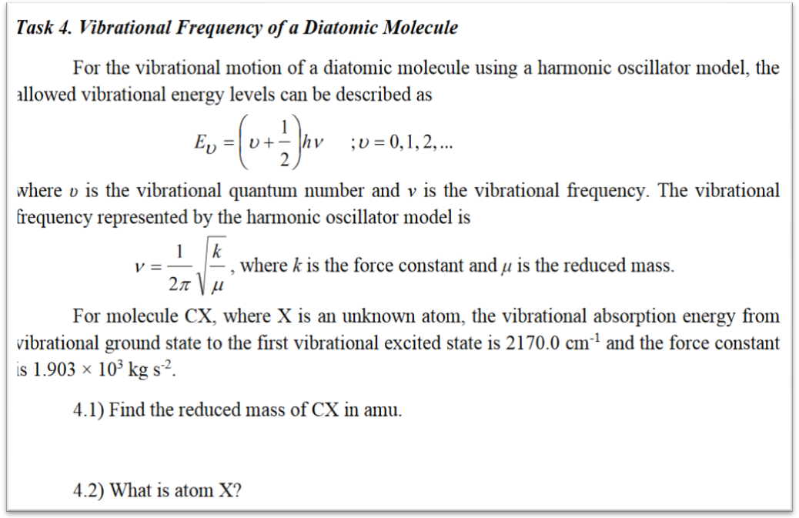
Task 4. Solution
4.1) Since ν is a frequency, it can be transformed to a wavenumber by dividing by the speed of propagation, or the speed of light. Then w = 2170.0 1/cm = 217000 1/m, and therefore we have ν = cw = 6.51×10¹³ 1/s. From the frequency, we can obtain the reduced mass of the molecule:
4.2) From the definition of reduced mass of a two interlinked particle system, we have:
The mass of one carbon atom (in kg) is given by the relation of its molar mass and Avogadro’s constant, thus m_{C} = MM_{C}/N_{A} = 0.012011 kg/mol / 6.022×10²³ 1/mol = 1.994×10^{–26} kg, then from the above equation we have m_{X} = 2.645×10^{–26} kg.
Its molar mass is thus MMx = m_{X}N_{A}= 15.93×10^{–3} kg/mol = 15.93 g/mol, which is close to 15.999 g/mol (99.6% accurate) or the molar mass of oxygen.
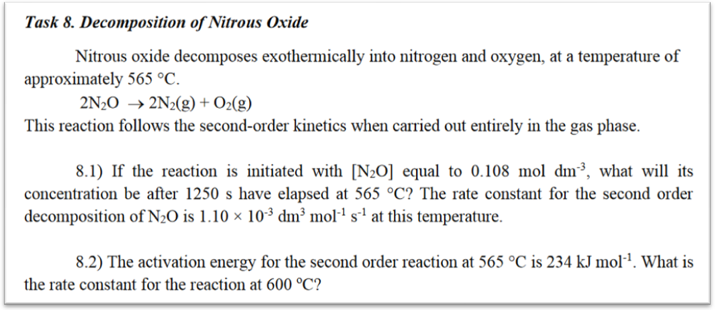
Task 8. Solution
8.1) Considering the forward reaction, the rate power-law describing the system would be:
The change in concentration of the reactant over time is written as:
The factor 2 is the stoichiometric coefficient of the reacting specie, and the negative sign is put since it’s a reagent in the forward reaction. The differential equation is separable, giving:
Now, plugging in the available data, we obtain the concentration of the main reagent:
8.2) The rate constant can be described as an Arrhenius-type relation, in which the activation energy scaled by RT. From this we obtain:
By direct substitution, the rate constant at the second temperature is obtained, and since temperature increases, so will be the rate constant:
Thus, the rate constant has shown consistent behavior with the initial observation.
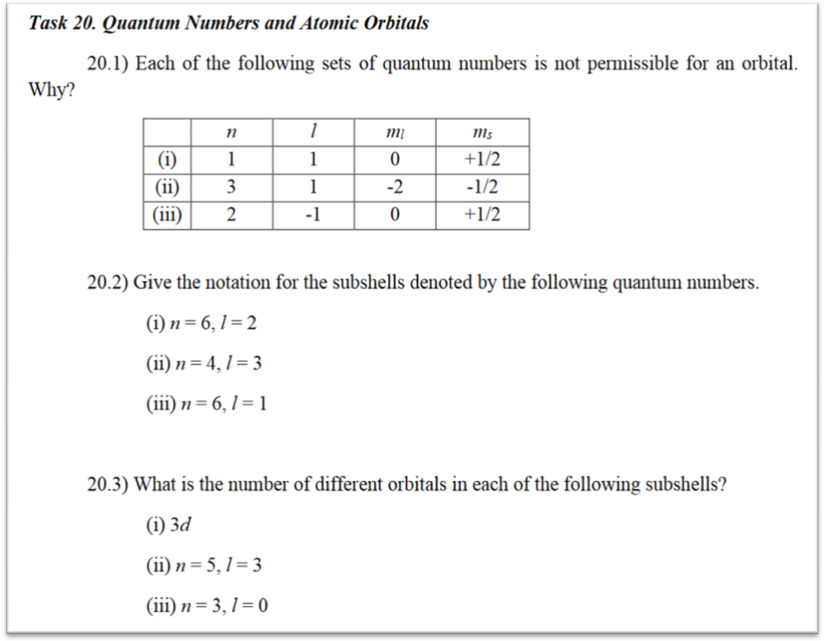
Task 20. Solution
20.1) The rules to list the classical quantum numbers are the following:
n principal n> 0, n integer
ℓ orbital 0 ≤ ℓ <n – 1, ℓ integer
m_{ℓ} angular (1 –ℓ) ≤ m_{ℓ} ≤ (ℓ – 1), m_{ℓ} integer
m_{s} spin (for electrons) m_{s} = ± ½
From this, row (i) has ℓ = n (violation), row (ii) has m_{ℓ}<– (ℓ – 1) or m_{ℓ}< –1 (violation), and lastly (iii) has ℓ negative (violation).
20.2) We proceed in numbering by each item point:
(i) has n = 6 and ℓ = 2, thus the subshell is 6d
(ii) has n = 4 and ℓ = 3, thus the subshell is 4f
(iii) has n = 6 and ℓ = 1, thus the subshell is 6p
20.3)We proceed in numbering by each item point:
(i) has n = 3 and ℓ = 2, thus it has 2ℓ + 1 = 5 orbitals
(ii) has n = 5 and ℓ = 3, thus it has 2ℓ + 1 = 7 orbitals
(iii) has n = 3 and ℓ = 0, thus it has 2ℓ + 1 = 1 orbital

